FARAJA CANCER SUPPORT TRUST
EXTRACTS FROM THE ANNUAL AUDITED REPORT
cindy ogana- fundraising manager
MAY 2017 - APRIL 2018

A word from the Chairman, Faraja Board of Trustees-Andrew Hollas

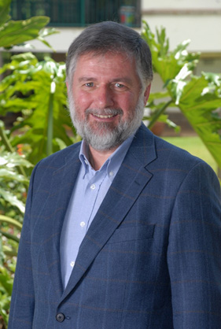
Faraja, plays a complementary role in supporting cancer patients as they undergo medical treatments. We do this by providing emotional, practical, and healing support for patients and their caregivers. Through information, counselling, support groups, complementary therapy sessions, and our Medical Support Fund, patients are helped in their journey. The understanding that there is life after cancer forms a core part of our programs.
As from October 2017, Faraja started supporting patients financially for medical treatment through our Faraja Medical Support Fund. We also expanded our complementary programs and partnered with other support groups in bringing hope, help and life to cancer patients and their caregivers.
The year to 2018 has been another successful year for Faraja thanks to the efforts of our core team and volunteers who offer any patients who seeks our services a sympathetic ear, a shoulder to lean on and the best care that we can offer. Thank you so much for your efforts and support.
The Financial Statements highlight our successful fund raising and how we have used those funds efficiently and effectively in the provision of services.”
A word from the Founding Trustee- Shaira Adamali
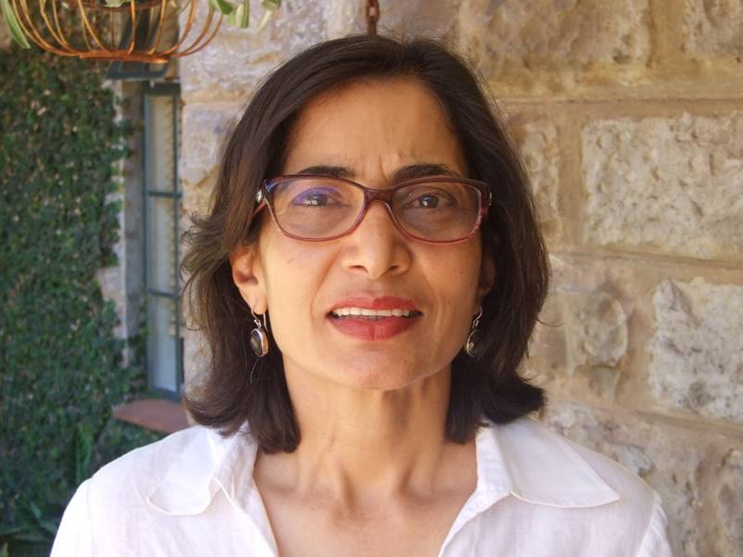
This financial year we managed to raise Kshs. 7,708,314 from our two core fundraising activities: White Water Rafting and Kenya’s Biggest Coffee Morning. In addition, we have friends of Faraja who raised an additional Kshs 2,959,164. A total of Kshs. 10,677,478 was raised. We also managed to raise Kshs 24,261,662 for our medical fund. These funds were used to finance our programs namely: 6 support groups, bi weekly art and music therapy program at Kenyatta national hospital children’s oncology wards and our medical assistance program. We continue to minimize our administrative costs through the dedication and hard work of our small core team and our many volunteers. The Trustees, staff and the rest of the team at Faraja Cancer Support Trust want to extend their heartfelt gratitude to everyone who shared their incredible generosity with us this year by giving us their time, finances and participating in our programs and events. Your support continues to make a huge difference in the lives of cancer patients and caregivers who access our services. We cannot do what we do without you. On behalf of everyone we serve – THANK YOU
About us
The Faraja Cancer Support Trust was founded in 2010 with the aim of providing emotional, practical and healing support to anyone affected by cancer. Faraja offers services to complement medical treatment through information, free complementary therapies, support groups meetings, art/music therapy and food aid for inpatient oncology children at Kenyatta National Hospital and financial assistance for medical treatment. Our premises provide a safe haven for cancer patients and their caregivers to access our free services, which has enabled us to make a positive difference in the journey of over 10,000 cancer patients. Our long-standing relationships with a variety of supporters make us sustainable. We are here for the long term. We bring help, hope and life.
Our Vision
A safe haven accessible to anyone affected by cancer.
Our Mission
To improve the physical, emotional and social well-being of cancer patients, cancer survivors and their caregivers through the provision of high quality complementary therapeutic treatments and counselling services. Faraja's goal is to reach and improve the lives of everyone living with cancer in Kenya

Faraja Cancer Support Trust: Programs
Faraja’s activities are anchored around 5 main pillars:
Information- Most cancer patients and their caregivers do not understand sufficiently what they are going through and have many questions. Our well stocked resource library provides information on all types of cancers as well as demystifies jargons and myths.We aim to be the one stop shop on cancer related publications and books. Access to our library is free.

Complementary therapies- Complementary therapies are used to help cancer patients manage symptoms, reduce side effects and restore a sense of control and vitality.
Support Groups- Faraja has 6 main support groups. Breast, Cervical and Prostate Cancer meet once a month, Head and Neck and Blood Cancers Support Group meet every quarterly and every Friday morning, we have a parent’s support group at Kenyatta.
Crafts for Cure- This is a weekly art/music therapy program that takes place every Wednesday and Friday at KNH’s Children’s oncology wards. Faraja volunteers engage the children in arts and crafts; music and dance, aimed at helping them cope with the side effects of treatment. Every Friday we also give milk and fruits to about 300 children at KNH.
Medical Assistance -On the 12th of November 2016, Faraja officially launched its medical fund the “Faraja Medical Support Fund.” This is a corpus of funds that when invested, will ensure effective and timely treatment for up to 50 cancer patients a year, forever. Please read some of the patient’s testimonies below.

Our Fundraising Activities: How we raised our money
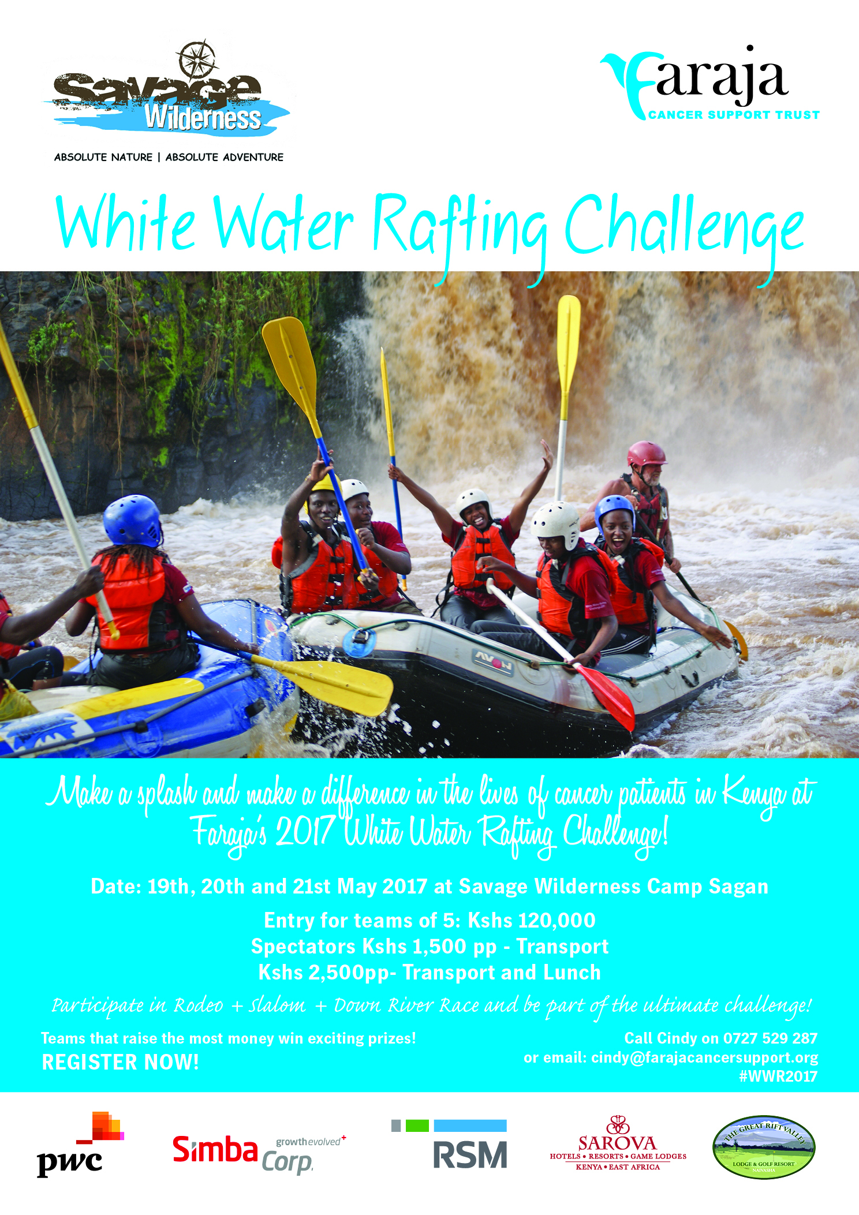
To sustain our programs, various activities take place to raise funds throughout the year. Faraja has identified two main fund raising events held annually: White Water Rafting in May and Kenya’s Biggest Coffee Morning in September and October. These two main events cover most of our running costs .We also have friends of Faraja who put together fun activities, social events, dinners and golf days for raising funds for Faraja.

White Water rafting
Our annual white water rafting challenge was held in May 19th, 20th and 21st 2017 at Savage Wilderness Camp. We registered 39 teams and raised Kshs 3.68 million. Compared with 2016 when we registered 35 teams and raised Kshs 2.8 million. We were supported by more silver sponsors: Simba Corp, PwC, RSM, Great Rift Valley Lodge, and Sarova Hotels. A total of 500 spectators attended the weekend.
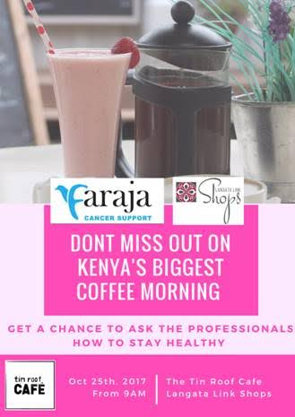
Kenya’s Biggest Coffee Morning (KBCM)
Kenya’s Biggest Coffee Morning was held from September to November 2017.
We had a total of 49 hosts representing banks, insurance companies, professional services firms, schools, private businesses, and individuals.
A total of Kshs 2.8 million was raised, a drop from the previous year’s Kshs 3.2 million, probably due to the prolonged electioneering period. A total of about 700 people attended or participated.

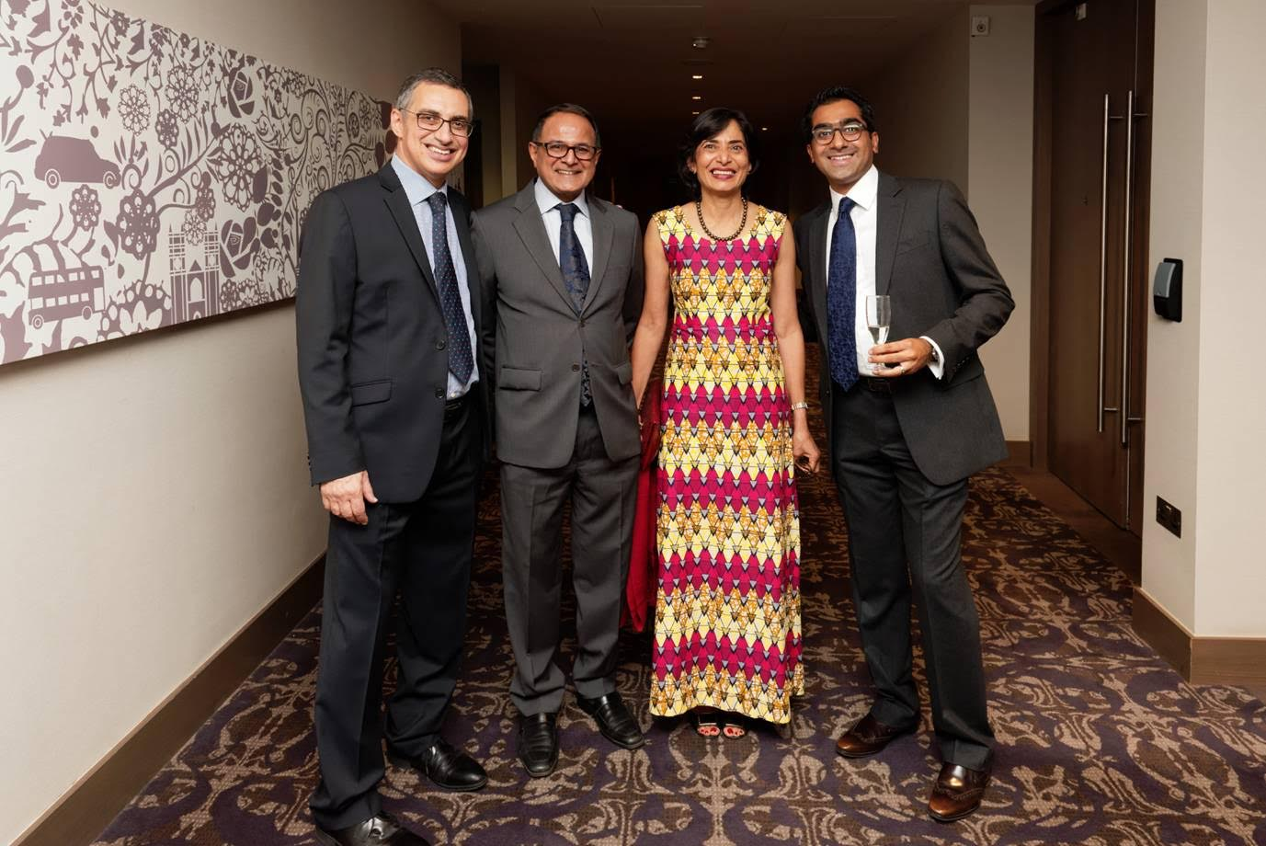
London Gala Event
On Saturday the 14th of October 2017 two oncologists, Dr. Andreas Makris and Dr. Neel Bhuva, from the Mount Vernon Cancer Centre in London, UK, organised a gala event and fundraiser. Both doctors are oncologists specialising in breast cancer research and gastrointestinal malignancies respectively.
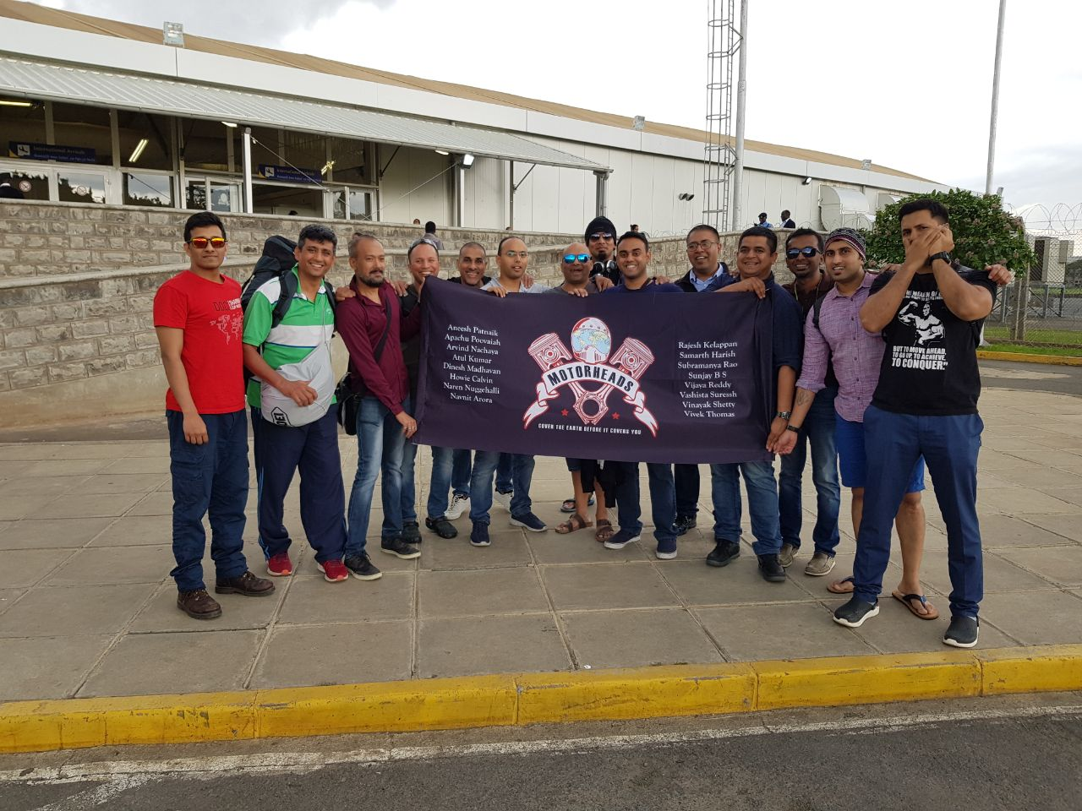
The event in London was attended by 250 people, £35,000 (Shs 4.5m) was raised. These funds, a contribution to our Medical Support Fund, will provide medical treatment for two patients every year, forever. The event was a great pre-cursor to Faraja being registered in as a UK charity enabling us to receive donations directly to a UK account and donors, who are UK taxpayers, will qualify for gift aid.
Motor Heads Bike Ride
In April 2018, a group of motorcycling enthusiasts – Motorheads - set out on a journey across Kenya to promote awareness and solidarity in the fight against cancer. The Bike Ride took 6 days, traversing Voi-Malindi - Amboseli-Naivasha- Nakuru and back to the Nairobi. A total of 16 bikers participated and raised Kshs 515,000.

Christmas Cricket Cracker Jeremy and Jason Holley organised a cricket tournament at Nairobi Club in December 2018. A total of Kshs 350,000 was raised for the Medical Support Fund.
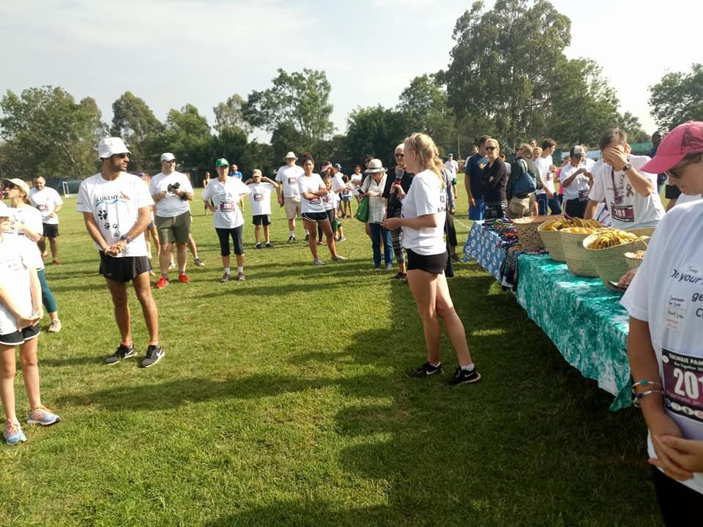
Family Fun Run
In January 2018, Faraja Club, a new club formed by students of International School of Kenya organised a family fun run at their Nairobi Campus and raised Kshs 172, 450. The monies were used for our Crafts for Cure Program at Kenyatta National Hospital. The Fun Run will be a yearly event.

Our Programs
Support Groups
Breast Cancer Support Group: The Breast cancer support group continues to be our most vibrant group with attendance increasing every year. In the year a total of 720 Breast cancer survivors attended.
Prostate Cancer Support Group: The group has continued to grow steadily with an attendance of 300 annually.
Head and Neck Cancer Support Group: This is a new group that was started in 2017. The group is slowly picking up due to increased cases of head and neck cancers. The groups meet once every three months,
Multiple Myeloma, Leukemia and Lymphoma Group: The blood cancers support group was started to respond to a need for support for patients with Multiple Myeloma, Leukemia and Lymphoma. The group continues to grow and 72 survivors attended the meetings in the year. The groups meet once every three months.
Cervical Cancer Support Group: In the year we had 240 cervical cancer patients attending the support group. Many survivors shy away from attending meetings, which we combat by having more speakers address the issue and building on the esteem of the attendees.
Support Group for parents at Kenyatta: We started a support group for parents who have children at Kenyatta Hospital. A total of 540 parents attended the support groups. They have proven to be a source of information and comfort to parents who do not have any other outlet to discuss their problems.
Wellness Therapies
There has been continued uptake of individual therapies. We managed to add new therapies such as osteopathy, Om Chanting, Tai Chi and Twin Hearts meditation. We also have more therapists for lymphatic drainage and massage.
Crafts for Cure
The Craft for Cure at Kenyatta National Hospital has continued to grow with a steady number of volunteers. The decision to work with interns and volunteers was strategic and helped have a committed and consistent team. We saw a total of 5,200 kids. We added grief counselling to our art therapy program to help the children in the wards cope with losing a bed mate or a friends.
Testimonies
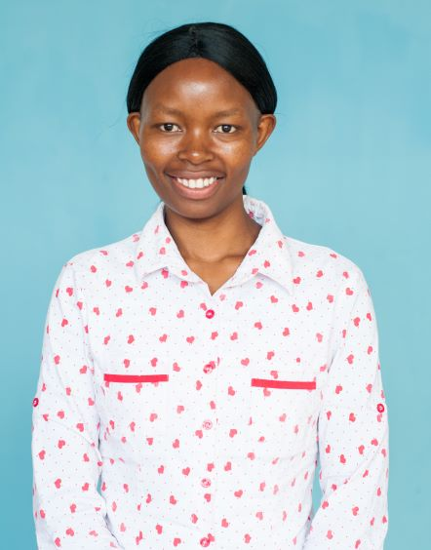
Here are a few testimonies of patients who received support from the Faraja Medical Support Fund

In 2013, Fridah first felt a lump in her left breast, close to her nipple. She went to the hospital and underwent a biopsy but the results were benign. She was however advised to consider having a second baby but was not told why. Since she was not ready to have another child, she chose to wait it out, hoping the lump would disappear on its own and it did. All was forgotten until she became pregnant in 2017.
You can read more about her story here
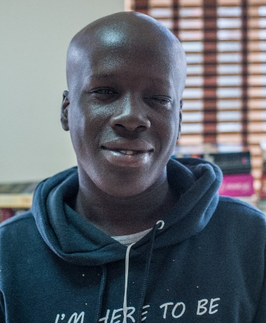
Ronald was looking forward to joining Kabete Technical College in September of 2018 to study a course in Engineering. But in July of 2018, his left eye became constantly itchy. He used home-based remedies, thinking it was only an allergic reaction but the itch became worse and his eye started to swell causing his vision to become blurry.
Read more about this teenager's story here

How we spent our money
In 2018 a total of Ksh 34,929, 140 compared to Ksh 46,824,088 raised in the FY2017. Some factors affecting this were: extended electioneering period experienced from 8th August to October 17th 2017 which significantly affected our Kenya’s Biggest Coffee Morning campaign.

Our annual Royal Fusion Gala ball was also affected by electioneering and subsequently cancelled,140 was raised. This was a decrease.

Our expenditure in the year ended April 30th 2018 was Shs14m the graph shows where we spent this.

Events Calendar 2018/2019
Launch of the Faraja Centre in Eldoret at Moi Teaching and Referral Hospital (MTRH)
Faraja is extending its services to another major urban centre. We have signed our lease with MTRH and are set to move in by the end of 2018.
White Water Rafting
Our annual fundraiser will still be at Savage Wilderness Camp in Sagana in June 2018.
Kenya’s Biggest Coffee Morning
Our annual awareness and fundraising campaign will begin in September through to November 2018.
Friends of Faraja initiatives
The Christmas Cracker by Jeremy and Jason Holley will take place on 1st and 2nd December 2018 at the Nairobi Club.
The ISK Family Fun Run is scheduled to take place in January 2019.
We also anticipate funds from the Movember campaign in November 2018.

